Documentation for the Network Communication analyzer

Olivér Izsák

Slovenská technická univerzita v Bratislave

Fakulta informatiky a informačných technológií

xizsak@stuba.sk

20. oct. 2022

1.Assignment

Original form:

Task assignment
Design and implement Ethernet network analyzer for network communications recorded in
.pcap file and provides the following information about the communications. A fully
developed assignment fulfills the following tasks:
1) A listing of all frames in hexadecimal form sequentially as they were recorded in the file.
For each frame, output should state:
a) Sequence number of the frame in the parsed file.
b) The length of the frame in bytes provided by the pcap API, as well as the length of
this frame carried over the medium. (these values may not be the same)
c) Frame type - Ethernet II, IEEE 802.3 (IEEE 802.3 with LLC, IEEE 802.3 with LLC and
SNAP, IEEE 802.3 - Raw).
d) For IEEE 802.3 with LLC, also indicate the Service Access Point (SAP), e.g. STP, CDP,
IPX, SAP...
e) The source and destination physical (MAC) addresses of the nodes between which
the frame was transmitted.
Other requirements:
f) In the output, the frame 16 bytes per line. Each line is terminated by a newline
character. For the clarity of the output, it is recommended to use a nonproportional (monospace) font.
g) The output must be in YAML.
h) The solution to this task is to be presented in the 4th exercise.

2) List of IP addresses and encapsulated protocol on layer 2-4 for Ethernet II frames.
For each frame, add the following information to the output from Task 1:
a) Encapsulated protocol in frame header. (ARP, IPv4, IPv6 .... )
b) Source and destination IP address of the packet.
c) For IPv4, also specify the encapsulated protocol. (TCP, UDP...)
d) For the 4th layer i.e., TCP and UDP, indicate the source and destination port of the
communication and if one of the ports is among the "well-known ports", also
Include the name of the application protocol.

Other requirements:
e) Protocol numbers within Ethernet II (Ethertype field), in IP packet (Protocol field)
and port numbers for transport protocols must be read from one or more external
text files (Task 2 points a, c, and d). Example of possible external file formatting is
at the end of this document.
f) Output also names in addition to numbers for well-known protocols and ports (at
minimum for the protocols listed in tasks 1) and 2). The program shall output name
of encapsulated protocol previously unknown protocol after its name and protocol
(or port) number are added to the external file.
g) A library file used by the program is not considered an external file.

3) Provide the following statistics for IPv4 packets at the end of output from task 2):
a) A list of IP addresses of all sending nodes and number of packets each sent.
b) The IP address of the node that sent (regardless of the recipient) the most packets,
and number of packets. If there are more that sent the most, list them all.
Note: The IP addresses and the number of sent / received packets must match the IP addresses in
the Wireshark -> Statistics -> IPv4 Statistics -> Source and Destination Addresses .

4) Your program with communication analysis for selected protocols:
Pre-preparation:
a) Implement the "-p" (as protocol) CLI option, which will be followed by another
argument, namely the abbreviation of the protocol taken from the external file,
e.g. analyzer.py -p HTTP. If the option is followed by any argument or the specified
argument is a non-existent protocol, the program will print an error message and
return to the beginning. Alternatively, a menu can be implemented, but the output
must be written to a YAML file .
If the argument following "-p" option specifies connection-oriented protocol
communication (i.e. encapsulated in TCP):
b) List all complete communications with their order number. Complete
communication must include establishment (SYN) and termination (FIN on both
sides; or FIN and RST; or RST only) of the connection. There are two ways for
opening and four ways for closing a complete communication.
c) List the first incomplete communication that contains only the connection
establishment or only termination.
d) Your analyzer must support the following connection-oriented protocols: HTTP,
HTTPS, TELNET, SSH, FTP radiation, FTP data.

e) The output for each frame of the communication must also meet the requirements
in Tasks 1 and 2 (L2 and L3 analysis).
Note 1: By default, the connection is opened using a 3-way handshake , 3 messages are sent
together, but it may happen that 4 messages are sent, for more information, see the whole chapter:
TCP Connection Establishment Process : The " Three-Way Handshake " .
Note 2: The connection is closed using a 4-way handshake , but two situations can occur, see the
entire chapter: TCP Connection Termination or using a 3-way handshake . The connection can also
be terminated using a flag RST .
Note 3: The packet that initiates the start of the connection termination process may have other
flags set, such as PUSH, in addition to the FIN flag.

If the argument following "-p" option specifies connectionless protocol (over UDP):
f) For the TFTP protocol list all frames and clearly list them in communications, not
only the first frame on UDP port 69, but identify all frames for each TFTP
communication and clearly show which frames belong to which communication.
g) The output for each frame of the communication must also meet the requirements
in Tasks 1 and 2 (L2 and L3 analysis).

If the argument following "-p" option specifies ICMP protocol:
h) The program identifies all frames of one ICMP communication and will be able to
clearly show in the output which frames belong to which communication. If you
identify an incomplete ICMP communication, you will report it as incomplete.
i) For each ICMP frame, also indicate the ICMP message type ( Type field in the ICMP
header), e.g. Echo request , Echo reply , Time exceeded , etc.

If the argument following "-p" option specifies ARP protocol:
j) List all ARP pairs (request – reply), also indicate the IP address for which the MAC
address is being sought, for Reply indicate a specific pair - IP address and MAC
address found. If multiple Request frames were sent to the same IP address, list
them all. If there are Request frames without corresponding Reply (or vice versa
Reply without Request), list them all separately as incomplete communications.

2. Methods,structures,libraries

Libraries used:
I used some basic libraries such as:
#include <stdio.h>
#include <pcap.h>
#include <string.h>
#include <stdlib.h>

Structures:

Some basic structures to contain the information from the packets. When putting the bytes into them thanks to the way structures work in c, they go in the same order and only taking up the specified amount of bytes in each variable.
struct ethernet {
u_char dmac[6];
u_char smac[6];
u_short EtherType;
};

struct IE3
{
u_char dsap;
u_char ssap;
u_char ie3Control;
u_char ie3Vendor[3];
u_short ie3EtherType;

};

struct arp {
u_short hwType;
u_short protType;
u_char hwAddrLen;
u_char protAddrLen;
u_short operation;
u_char srcHwAddr[6];
u_char srcProtAddr[4];
u_char tarHwAddr[6];
u_char tarProtAddr[4];
};
struct icmp {
u_char type;
u_char code;
u_short checksum;
};
struct ip {
u_char versionAndIHL;
u_char TypeOfService;
u_short TotalLength;
u_short id;
u_short offset;
u_char timeToLive;
u_char protocol;
u_short checksum;
u_char srcAddr[4];
u_char destAddr[4];
};

struct tcp {
u_short srcPort;
u_short destPort;
u_int32_t sequenceNo;
u_int32_t ackNo;
u_short offsetReservedFlag;
u_short window;
u_short checksum;
u_short urgentPointer;
};
struct ip6 {
u_char versionTrafficFlow[4];
u_short payloadLength;
u_char NextHeader;
u_char HopLimit;
u_char srcAddr[16];
u_char destAddr[16];

};
struct HTTPList {
u_short frameNo;
struct tcp* current;
struct tcp* next;
};

struct udp {
u_short srcPort;
u_short destPort;
u_short length;
u_short checksum;
};

struct ipAddresses //This is a linked list needed to keep track of
{ communication.
u_char srcIp[4];
u_char destIp[4];
int frames[20];
int num;
struct ipAdresses* next;
};
Methods:

I used 6 different main methods:

int getFrameType(u_short type, u_char* payload) – This one is responsible for determining the type of frame we are reading (Ethernet II, IEEE 802.3 Raw/LLC/LLC +Snap). It returns 1 if its Ethernet II,2 if , IEEE 802.3 Raw, 3 if , IEEE 802.3 LLC+SNAP and 4 if IEEE 802.3 LLC

char* getProtocol(u_short number, FILE* protocols, char* sign) –
This method returns the protocol name, which can be found in the protocol.txt file, in string format. It goes through the txt file, and searches for the sign which was given as an argument. If it find the sign, then it will check if the list below that sign contains the number argument, if it does, it returns the string found after the „–„ sign.

void printout(int packetAmount,int plength,int mlength,u_short type, u_char* payload,struct ethernet* header,char* typeName,struct ip* ipv4,FILE* protocols,FILE* output) -
Printout method,just prints out the information about the analzyed packet in the command line , and into a Output.txt file.

u_short bitSwap(u_short etherType) –
This method is used for swaping some of the the bits that were read from the pcap file, because C reads it backwards when converting to decimal.

u_short calculateICMP(u_char val)-
ICMP protocol can have varying lengths before the bytes that contain the type of the icmp. So this method is needed to calculate the exact position of that byte in the frame.

struct ipAddresses* getList(u_char* packet,struct ipAddresses* pairs,int packetCount,int choice,struct ipAddresses* current,char end) –
This method was used for the 4a-i tasks for the assignment. I go through the pcap file 2 times, when analyzing for these tasks. So when the first time I go through the pcap file, I look for specific protocols (depending on which task was pressed at the beginning) and I use this method to write them in the IpAddresses structure. And structure them in based on communication.

The following methods are responsible for writing out the communication for their respective protocol:
Each method has the following parameters: returnValue, which is used for looping through the pcap file, pcap file itself, pcap headeer, packet that contains the data of one row from the pcap file, packetCount keeps track of the packet amount, pairs contains communications of a specific type bundled together, protocol.txt file, output file, k is used for separating complete and incomplete communications, file is the pcap file opened, int is for deciding if the communication was complete or incomplete

void ICMPCommunication(int returnValue, pcap_t* pcap_file, struct pcap_pkthdr* header, u_char* packet, int packetCount, struct ipAddresses* pairs, FILE* protocol, FILE* output,int k,int complete)

void ARPCommunication(int returnValue, pcap_t* pcap_file, struct pcap_pkthdr* header, u_char* packet, int packetCount, struct ipAddresses* pairs, FILE* protocol, FILE* output, int k, char* file, int complete)

void TFTPCommunication(int returnValue, pcap_t* pcap_file, struct pcap_pkthdr* header, u_char* packet, int packetCount, struct ipAddresses* pairs, FILE* protocol, FILE* output, int k, char* file, int complete)

void FTPDATACommunication(int returnValue, pcap_t* pcap_file, struct pcap_pkthdr* header, u_char* packet, int packetCount, struct ipAddresses* pairs, FILE* protocol, FILE* output, int k, char* file, int complete)

void TELNETCommunication(int returnValue, pcap_t* pcap_file, struct pcap_pkthdr* header, u_char* packet, int packetCount, struct ipAddresses* pairs, FILE* protocol, FILE* output, int k, char* file, int complete)

void SSHCommunication(int returnValue, pcap_t* pcap_file, struct pcap_pkthdr* header, u_char* packet, int packetCount, struct ipAddresses* pairs, FILE* protocol, FILE* outputint k, char* file, int complete)

void HTTPCommunication(int returnValue, pcap_t* pcap_file, struct pcap_pkthdr* header, u_char* packet, int packetCount, struct ipAddresses* pairs, FILE* protocol, FILE* output,int k, char* file, int complete)

void HTTPSCommunication(int returnValue, pcap_t* pcap_file, struct pcap_pkthdr* header, u_char* packet, int packetCount, struct ipAddresses* pairs, FILE* protocol, FILE* output, int k, char* file, int complete)

void FTPControlCommunication(int returnValue, pcap_t* pcap_file, struct pcap_pkthdr* header, u_char* packet, int packetCount, struct ipAddresses* pairs, FILE* protocol, FILE* output, int k, char* file, int complete)

3. Mechanism for analyzing protocols on different layers.

Network Layer frame

The first layer that needs to be analyzed is the network access layer, where we have to determine the type of the frame which are the following :
Ethernet II
IEEE 802.3 Raw
IEEE 802.3 LLC
IEEE 802.3 LLC +Snap

The way its frame type can be determined is through the specific values that each frame type was given. Such as if the etherType value in is above 1536 then that frame is an Ethernet II frame.

If it is below 1500 and its DSAP starts with FF then it is IEEE 802.3 raw.

If it is below 1500 and its DSAP starts with AA, then it is IEEE 802.3 LLC + SNAP

And if it is neither of these 3. Then it is a IEEE 802.3 LLC

The mechanism of determining the frame types can be also described with the following flowchart which is also the flowchart of my getFrameType method:
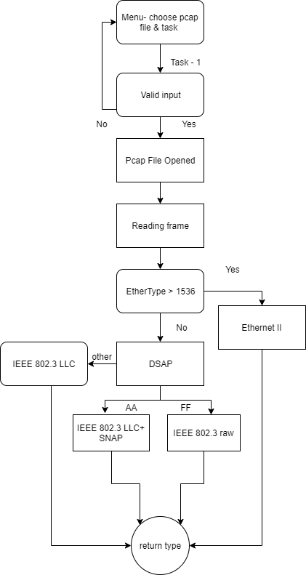

Tasks 1-3 Implementation

When the menu choice’s input from the user is 1, the program’s goal is to write out information about each packet and write out all the IP addresses that sent a packet which had Ipv4 protocol, and also to write out the one which sent the highest amount of packets.
This task was solved the following way:

We get each packet one by one through a loop, which continues until the packet is null.
While going through packets, we check each if they are Ethernet->Ipv4. If they are then we check the packet’s IP address and put into the linked list. If that ip address is already in the linked list, then we will increment the num variable in that node. This way we can keep track of how many packets that one IP address has sent.
If the packet is doesn’t have an ipv4 protocol then this part is skipped.
For each packet the protocol type will be checked and information written out in the command line and output.txt file depending on the protocols requirements. Eg.: For tcp port numbers will be written out.

When there are no more packets to be read, the program will go through the linked list, type out all the ip addresses and the one which has the highest amount of packets sent.
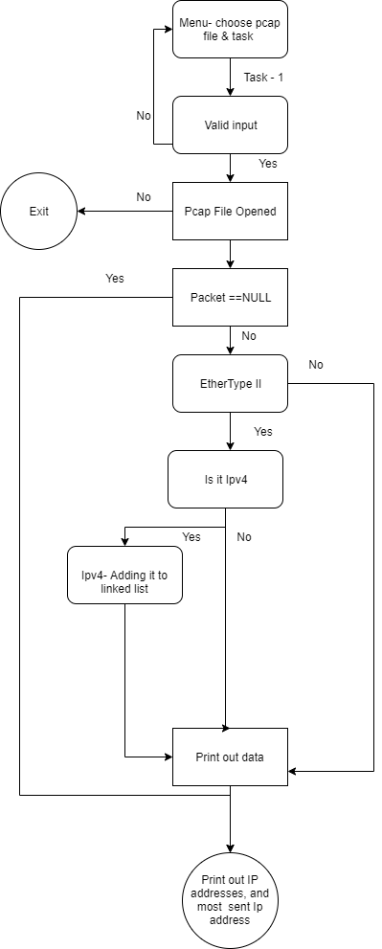

Tasks 4)a-f Implementation

These tasks were implemented through the use of loops,recursive functions and linked lists.
When the user gives an input from the range of 2-10. Then the program first will
loop through the whole pcap file. Examining each packets, whether they fit the description of the protocol that was tasked and calling the getList() method and putting them in a linked list.
Eg.: If input was 2. Then while going through the packets, my program will ignore any packets that doesnt have a HTTP protocol.
This function consists of 2 similiar parts. One is for arp packets, and other is for everything else.
The function does the following:
When a packet is added to it, it will check if its already in the linked list by checking the destination/source IP address.
If they match then that means this communication between this ip address pair is still ongoing.If they do not match, or the conversation has already ended (and it was restarted again) it will create a new node and it will add it to the list.
A node will be marked as „ended” depending on the protocol if its arp or icmp we will know if it ended if it got a reply. At tftp we know if the same IP address pair, contains the 69 port. And in TCP packets, it will contain a conversation end of (fin,ack or rest) sequences. When IP pair is added that is already in the list, and the communication has not yet ended, then it will be added in the structures frames int array with 20 slots. Which contains the number of the packet
After the program finished reading the pcap file. It will call one of the following functions(depending on the task chosen) :
2. HTTPCommunication()
3. HTTPSCommunication()
4. TELNETCommunication()
5. SSHCommunication()
6. FTPControlCommunication()
7. FTPDATACommunication()
8. TFTPCommunication()
9. ICMPCommunication()
10. ARPCommunication()

Each of these functions will reopen the Pcap file, and starts reading it again.
But this time it will compare each node’s stored frames and only write out the information about the one that match the packetnumber. And then the same function is called again, to go through the loop, until the next node is null.This way all the communication will be printed out in order.
These methods will be called 2 different times, once when looking for complete communications and once for incomplete ones. This was done like this because of the specific yaml format required it.

And this is a flowchart presenting the action of this protocol analyzing mechanism, it includes all the communication methods because they are very similiar:

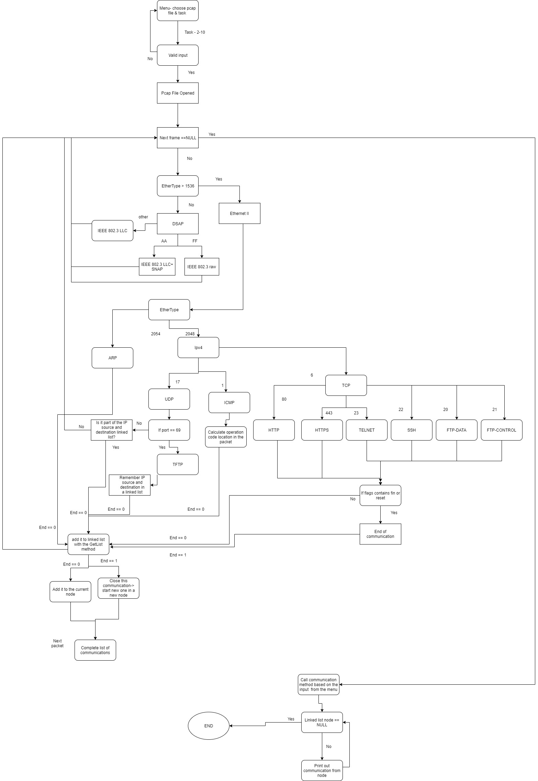

4.External files used

I only used 1 external file for the implementation of the assignment, which was used to store all the possible protocols/ethertypes/operations etc..
When a protocol is missing the program will list it as Undefined or Unknown. However if the list is updated with the missing protocol’s number in decimal then a dash sign and the name of the protocol or ethertypes, then it will work for the next execution.
In the extern file some signs have specific meaning. The specific meaning is written above the signs the lines between two different signs are ignored. The program searches for these signs and when it finds one it starts to checks the numbers to find the right protocol. If it once more finds the same sign that means the searched value is not written in the extern file.
My external file called Protocol.txt:
Ethertype
}
512=XEROX PUP
513=PUP Addr Trans
2048=IPv4
2054=ARP
2049=X.75 Internet
2053=X.25 Level 3
32821=ARP
32923=Appletalk
33011=Appletalk AARP
33024=IEEE 802.1Q VLAN-tagged frames
33079=Novell IPX
34525=IPv6
34827=PPP
34887=MPLS
34888=MPLS with upstream-assigned label
34915=PPPoE Discovery Stage
34916=PPPoE Session Stage
35020=LLDP
36864=ECTP
8192=CDP
}
LSAPs
{
0=Null SAP
2=LLC Sublayer Management / Individual
3=LLC Sublayer Management or Group
6=IP (DoD Internet Protocol)
14=PROWAY (IEC 955) Networ Management
66=STP
78=MMS (Manufacturing Message Service) EIA-RS 511
94=ISI IP
126=X.25 PLP (ISO 8208)
142=PROWAY (IEC 955) Active Station List Maintenance
170=SNAP
224=IPX
240=NETBIOS
244=LAN Management
254=ISO Network Layer Protocols
255=Global DSAP
267=PVSTP+
8192=CDP
8196=DTP
{
IP
+
1=ICMP
2=IGMP
6=TCP
9=IGRP
17=UDP
47=GRE
50=ESP
51=AH
57=SKIP
88=EIGRP
89=OSPF
11=5L2TP
+
ARP
!
1=REQUEST
2=REPLY
!
ICMP
%
0=REPLY
3=DestinationUnrechable
4=SourceQuench
5=Redirect
8=REQUEST
9=RouterAdvertisment
10=RouterSelection
11=TimeExceeded
12=ParameterProblem
13=Timestamp
14=TimestampReply
15=InformationRequest
16=InformationReply
17=AddressMaskRequest
18=AddressMaskReply
30=Traceroute
%
TCP
-
7=ECHO
19=CHARGEN
20=FTP DATA
21=FTP CONTROL
22=SSH
23=TELNET
25=SMTP
53=DOMAIN
79=FINGER
80=HTTP
110=POP3
111=SUNRPC
119=NNTP
139=NETBIOS-SSN
143=IMAP
179=BGP
389=LDAP
443=HTTPS
445=MICROSOFT DS
1080=SOCKS
-
UDP
(
7=Echo
19=Chargen
37=TIME
53=Domain
67=DHCP
68=DHCP
69=TFTP
137=NETBIOS-NS
138=NETBIOS-DGM
161=SNMP
162=SNMP-TRAP
500=Isakmp
514=SYSLOG
520=RIP
1900=SSDP
5355=LLMNR
546=DHCPv6
547=DHCPv6
33434=TRACEROUTE
(
IPV6
#
0=Hop-by-Hop options
43=Routing
44=Fragment
50=EncapsulatingSecurityPayload
51=Authentication
58=ICMPv6
59=NoNextHeader
60=DestinationOptions
6=TCP
17=UDP
#

5

5.User interface

The user interface is plain and simple:
When the program is executed it will ask the user to input the type of file he wants to analyze.
The possible types are: 1- eth , 2-trace, 3-other(which is trace_ip_nad_20_B )
Then the user has to choose the number of the file. (eth 1-9,trace- 1-27 )
The last step is for the user to type in the number representing the specific task he wants the program to do.

Picture of the UI:
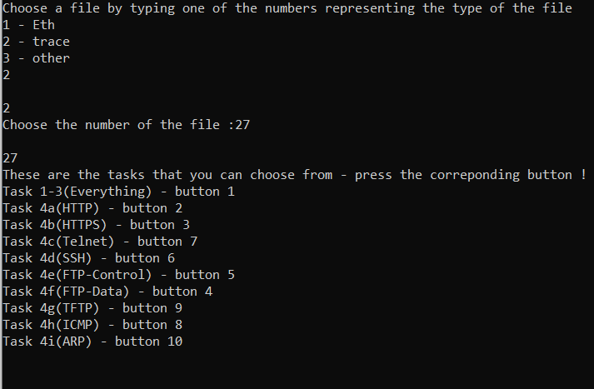

After that the program will execute the task and print out the specific information about the analyzed packets meanwhile will also do the same thing in a txt file called Output.txt:
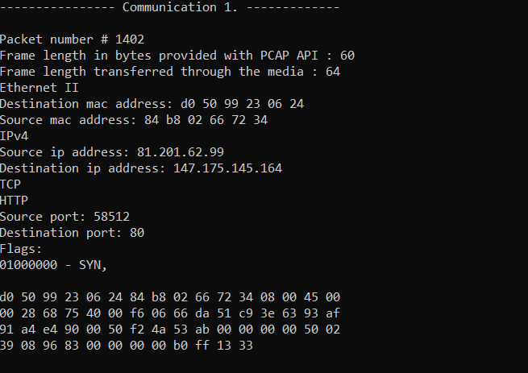
After the program finished writing it will go back to the menu so the user can choose another file/task again.
If the user writes atleast one 0 in the menu for the choices, the program will termintate.

6.Conclusion

As of the implementation environment I’ve chosen the language C. The reason behind it is that I already have experience with it.

I think my program is working and functioning without problems. It doesn’t crash if it can’t find a protocol. It is suitable for extension since if it can’t find a value in the protocol.txt, is just needs to be added. And then instead of printing out Undefined, it will print out the exact name of the newly added protocol.

I tried to use proper variable data type choices for the variables. Such as using char instead of char* or using u_short instead of int. There are some exeptions where I wasn’t sure which one to use, since it is possible to get an overflow for example for packet numbers. Since the limit for u_short is 65535, which is not entirely impossible to have in a pcap file. But its unlikely, and also in the pcap files we got for testing didn’t have one that would contain packets above 4000.

Even though my program is functioning perfectly I did make some mistakes, inefficiencies and ignored some best programming practices.

One inefficiency could be the extensive use of loops and linked lists.
Since the way my program works for the (4a-f tasks) is that is goes through the whole pcap file once. Looks for specific packets that the task is asking for, and puts them in a linked list.
After this is done, it goes through the pcap file again multiple times to print out each communication that the linked list contained.
And some of the pcap files have more than 300 communications, which means the program will loop through the pcap file more than 300 times.
So the program is not time or memory efficient.

Best practices that were not followed are: duplicate code.
All my communication methods are very similiar, except the print out, so they could have been put into one or 2 methods with a lot of if statements.
There is also some duplicate code in the getlist method, so it allocates memory differently based on arp or tcp packets.
And another best practices mistake is naming conventions, some of them are just variable k,x,m,o etc... Which can make it hard for others to understand.

